

**GEBZE TECHNICAL UNIVERSITY**

**DEPARTMENT OF COMPUTER ENGINEERING**

**CSE 312 /CSE504**

**Operating Systems**

**Homework #3 Report**

**171044073**

**Berkan AKIN**

**Problem**

FAT12 file system design will be done. In the book, the form of agriculture found in 4.30 and 4.31 will be discussed. file attributes will include size, last modification date and time, and name of the file. Define your directory table and directory entries; Define how and where you keep the free blocks; Define your super block that contains crucial information about the file system such as the block size, root directory position, block positions,etc

Write a C/C++ program that creates an empty file system as a (16 MB max) file. This file will include all the information about your file system including the super block, data blocks, free blocks, directories, data, etc.

**Solition**

The above mentioned problems have been done. Part1 and part2 tasks given in the homework were done, part 3 and part 4 were not done

**1)Disk Organization**

To simulate the disk, we have a .dat file. Therefore, we need to edit this file.

**Fat12 File System**

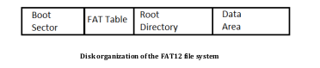

**1)Boot Sector**

This section of the system contains information about the file system, such as Bytes per Sector, Sectors per Cluster, and the number of Reserved Sectors. I will keep it simple and place the information based on the block size, as shown in the diagram (superblock).

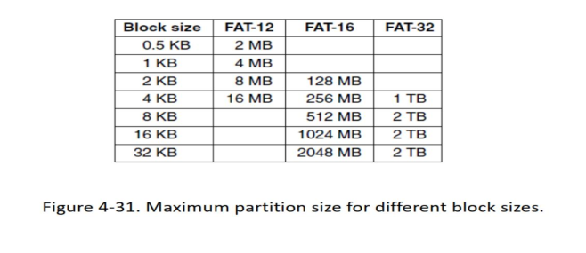

SuperBlock is the most important data structure of a file system. It is typically the first block created or encountered when a file system is created or mounted. The SuperBlock contains the fundamental properties and parameters of the file system.

The SuperBlock can include the following information:

Disk name or label: The name or label of the disk or partition used by the file system.

* Disk size: The total size of the disk or partition used by the file system.
* Block size: The size of the blocks in the file system. A block is the smallest unit of operation for a file.
* Number of entries: The total number of entries (files or directories) in the file system.
* Number of blocks: The total number of blocks in the file system.
* Total bytes: The total size of the file system in bytes.
* Boot sector position: The memory position or disk location of the boot sector located at the beginning of the file system.
* FAT table position: The memory position or disk location of the File Allocation Table (FAT).
* Root directory position: The memory position or disk location of the root directory.
* Data start position: The memory position or disk location where the data region starts.

The SuperBlock contains the configuration of the file system and the necessary information for placing files and directories. These details are important for ensuring the proper functioning of the file system.

**Code Snipped**

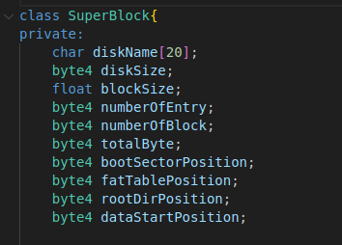

**2) FAT(File Allocation Table)**

FAT (File Allocation Table) is a data structure used in file systems. FAT is a table that tracks the allocation status of each cluster in a disk partition and manages the disk locations of files.

FAT keeps track of the scattered blocks of a file and their sequence on the disk. Each cluster represents the smallest unit in which a file is stored and typically consists of multiple sectors. FAT is used to determine the status of each cluster (such as free, occupied, or corrupted). A free cluster indicates an available space, while an occupied cluster represents a part of a file.

FAT is important for ensuring the integrity of file systems. During file system operations, the FAT table is updated to record the cluster numbers where files are stored in a distributed manner. The data blocks of a file are connected based on the specified sequence in the FAT table, enabling access to the file system and reading or writing files.

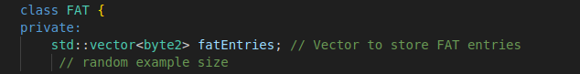

Random printing of certain segments of the table

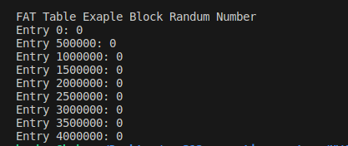

The directory entries will be like this and will total 32 bytes.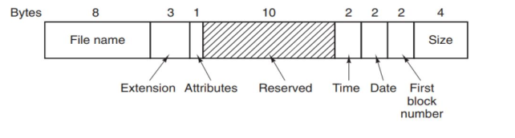

**Directory Entries Code Snippet**

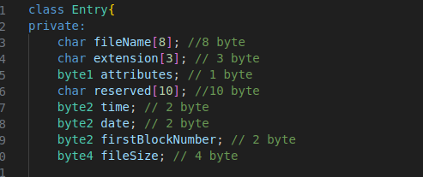

**Free Blocks in File System**

The bitmap data structure was used to keep track of empty blocks in the file system.



**Test Case**

**mySystem.dat file Information**

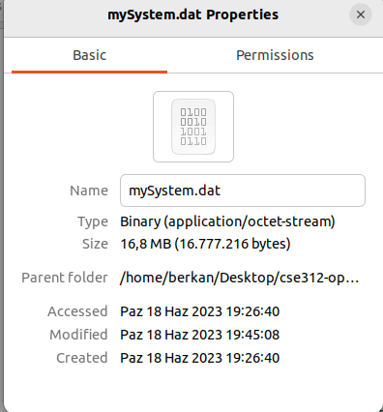

**Block Size 4**

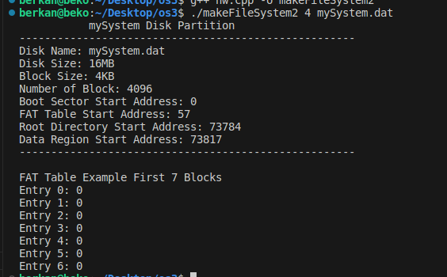

**Block Size 2**

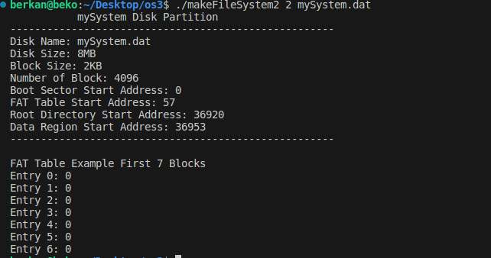

**Block Size 1**

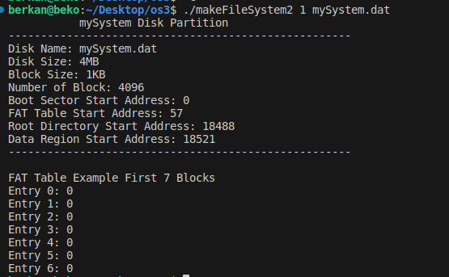

**Wrong Block Size**

